SS6 Financial Report and Analysis

Wednesday, June 30, 2021

12:28 PM

# READING 19. INTRODUCTION TO FINANCIAL STATEMENT ANALYSIS

##### LOS 21a: Describe the roles of financial reporting and financial statement analysis;

* + Role of financial report is to provide financial information about the reporting entity that is useful to existing and potential investors, leaders, and other creditors in making decisions about providing resources.
  + The ROLE of financial statement analysis is to use the information in FA, along with other info, to make economic decisions. (More about external users, but inner management also performs FA&FR)

##### B: describe the roles of the statement of financial position (balance sheet), statement of comprehensive income, statement of changes in equity, and statement of cash flows in evaluating a company’s performance and financial position;

* + BS, aka statement of financial position or statement of financial condition, reports the firm's financial position at the time. Assets = liabilities + owners' equity. **BS presents a shareholder’s residual claim on assets (residual interests on assets after deducting liability)**
  + Statement of comprehensive income reports changes in equity [business activities] except shareholders doing with stocks. Net income determined in the calculation of comprehensive income is a component of the change in retained earnings, but there are other changes that may also have occurred (the payment of dividends, for example) that are not included on the statement of comprehensive income.
  + 
  + IS, aka statement of operations or profit and loss statement. Revenues = other Income - Expenses
  + Cash flows: operating, investing, financial

##### C: describe the importance of financial statement notes and supplementary information—including disclosures of accounting policies, methods, and estimates— and management’s commentary;

* + Footnotes to improve their assessments of the **amount, timing, and uncertainty [accounting policies, methods, and estimates]** reported:
  + Discuss the basis of presentation, eg fiscal period or inclusion of consolidated entities
  + Accounting methods, assumptions, estimates

(SUMMARY: Business acquisitions or disposals, legal actions, employee benefits plan, contingencies or commitments, significant client, sales or segments)

* + financial instruments and risks arising from financial instruments,
  + commitments and contingencies,
  + legal proceedings,
  + related-party transactions,
  + subsequent events (i.e., events that occur after the balance sheet date),
  + business acquisitions and disposals, and
  + operating segments’ performance
  + **Management's commentary aka management's report, operating and financial review, MD&A(discussion and analysis)**: nature of business, objectives, past performance, performance measures, key relationships, recourses and risk. **Maybe unaudited**. US SEC **requires trends, significant events, uncertainties that affect** firm's liquidity, capital resources, operations. Eg:
  + Inflation & price changing
  + Off-Balance-Sheet obligations and contractual obligations - purchase commitments
  + Accounting policies needs judgement
  + Forward-looing expenditures and divestitures

##### D: describe the objective of audits of financial statements, the types of audit reports, and the importance of effective internal controls;

* + Standard auditor's opinions: 1. independent, 2. GAAS, reasonable assurance of no material errors, 3. accepted and reasonable, with additional explanation. **Sarbanes–Oxley**
  + **Unqualified** opinion (**clean** opinion): no material or errors

**Qualified** opinion: explains exceptions to the accounting principles

**Adverse** opinion: not fair or material

**Disclaimer** of opinion: unable to express opinions in the case of a scope limitation

* + Internal control: process that company ensures it presents accurate FA, responsibility of management. US SEC requires auditors to express opinions on internal control, can separately or 4th element of standard opinion.
  + Auditor:

1. Whereas the financial statements are prepared by management and are its responsibility, the auditor has performed an independent review.

2. Generally accepted auditing standards were followed, thus providing reasonable assurance that the financial statements contain no material errors.

3. The auditor is satisfied that the statements were prepared in accordance with accepted accounting principles and that the principles chosen and estimates made are reasonable. The auditor’s report must also contain additional explanation when accounting methods have not been used consistently between periods.

Unqualified 
Qualified 
Adverse 
Disclaimer 
of opinion 
• True and fairly presented 
• Clean opinion 
• Preferred by investors 
• Limited scope (incomplete records) 
• Exception from accounting standards 
• Explains degree and area of exception 
• Red flag on financial reporting quality 
• Material departure from accounting standards 
• Pervasive errors 
• Fraudulent or illegal activities 
• Unreliable financial statements 
• Unable to issue an opinion 

##### E: identify and describe information sources that analysts use in financial statement analysis besides annual financial statements and supplementary information;

* + Quarterly or semiannual reports (10-Q, 10-K): not audited, but **update**. 8-K of acquisitions and disposal.
  + **Proxy** statements: issued to shareholders for voting, about election & qualifications of board members, compensation, management, issuance of stock options
  + Corporate reports, press release: public relations or sales materials
  + **Earnings guidance**, before FA, a conference all of senior management to answer questions

##### F: describe the steps in the financial statement analysis framework.

* + State the objective and context
  + Gather data (ask questions about management, suppliers, customers)
  + Process the data (calculate ratios, prepare graphs and common-size BS)
  + Analyze and interpret the data (conclusions and recommendations)
  + Report the conclusions or recommendations (prepare report and talk, comply with code&standards)
  + Update the analysis (aka **follow-up**, repeat)

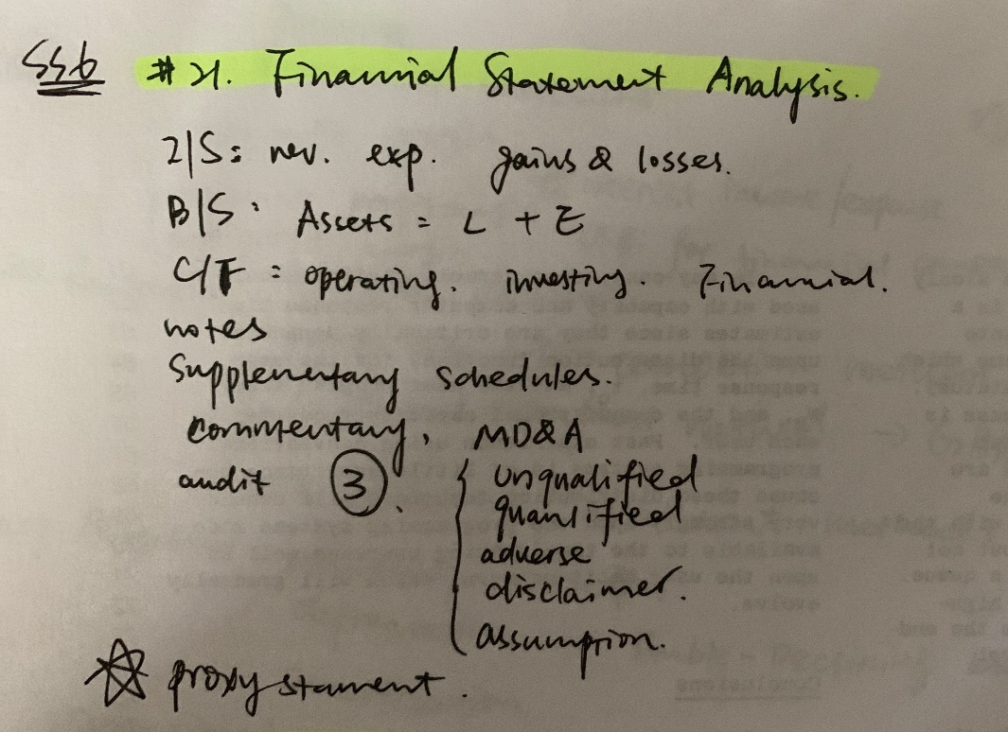

# READING 20. FINANCIAL REPORTING STANDARDS

##### A: describe the objective of financial reporting and the importance of financial reporting standards in security analysis and valuation;

* + To provide economic decision makers with useful info about financial performance and changes in financial positions. Reporting standards ensures diff firms are comparable, narrowing the range of reasonable estimates.

##### B: describe the roles of financial reporting standard-setting bodies and regulatory authorities in establishing and enforcing reporting standards;

* + Standard-setting bodes: professional org of accountants and auditors, 1 FASB - GAAP, 2 IASB - IFRS/IAS
  + Regulatory authorities: SEC, FCA(UK), International Organization of Securities Commissions(IOSCO) - 1. protect investors, 2. ensure fairness efficiency transparency, 3. reduce systemic risk
  + 10-K(needs audit), 10-Q, **DEF-14A (proxy)**, 8-K (disclose material events of acquisitions, disposals, changes in corp gov, security markets), 6-K(foreigner 10-Q), Form 144 (securities to qualified buyers without registering but notifying), Forms 3/4/5 (beneficial ownership)

##### C: describe the International Accounting Standards Board’s conceptual framework, including qualitative characteristics of financial reports, constraints on financial reports, and required reporting elements;

* + Fundamental qualitative characteristics: 1. relevance (predictive value/confirmatory value or both, **materiality**), 2. faithful representation (complete, neutral, free from error)
  + Enhancing characteristics: 1. comparability (consistent among firms and over time), 2. **verifiability** (same - different knowledgeable and independent users would agree that the information presented faithfully represents the economic events that it is intended to represent), 3. timeliness (information is available to decision makers before information is stale), 4. understandability (useful info cannot be omitted cuz complicated)
  + Required reporting elements: assets, liabilities, equity - for measuring financial positions, income, expense - for measuring performance.
  + Amount reported depend on **measurement base**: historical cost, amortized cost (hist adjusted for depreciation, amortization, depletion, impairment), current cost, net **realizable** value (in an orderly disposal, estimated selling), present value (discounted value of expected FV), fair value.
  + **Constraints**: cost-benefit tradeoff, non-quantifiable reputation (Balancing of qualitative characteristics)
  + Assumptions: accrual accounting (at time actually occur), going concern (firm will continue)

##### D: describe general requirements for financial statements under International Financial Reporting Standards (IFRS)

* + Required FA: BS, comprehensive IS, Cash Flow (like use direct format of CFO), changes in owner's Equity, explanatory notes, including a summary of accounting policies
  + Features for preparing: fair presentation, going concern basis, accrual basis (used to prepare financial statements other than statement of cash flows), consistency, materiality (free of mis or omissions), aggregation of similar and separation of dissimilar, no offsetting, frequency, comparative info, classified BS (distinguish between current and past), **minimum** info shown, comparative info
  + Barriers to create a coherent FRF: valuation, standard setting (**principles-based IFRS**, rules-based, objectives-oriented blend two **GAAP**), measurement.

##### E: describe implications for financial analysis of alternative financial reporting systems and the importance of monitoring developments in financial reporting standards.

s5'V4 一 
彐 丁 

# READING 21. UNDERSTANDING INCOME STATEMENTS

* + Describe the components of the income statement and alternative presentation formats of that statement
  + IFRS = GAAP similar: IS com be combined with other comprehensive income in a single one.
  + Net revenue = revenues - adjustments for estimated returns & allowances (aka turnover); Net Income (earnings, or 'bottom line') = revenues - ordinary expenses + other income - other expenses + gains - losses
  + Noncontrolling interest (aka minority interest, minority owner's interest) of subsidiary's inc reported in parents' companies IS, and needs to subtract calculating NI.

Revenue 
Cost of goods sold 
Gross profit 
Selling, general, and administrative expense 
Depreciation expense 
Operating profit 
Interest expense 
Income before tax 
Provision for income taxes 
Income from continuing operations 
Earnings (losses) from discontinued operations, net of tax 
Net income 
$579,312 
(362.520) 
216,792 
(109,560) 
(69.008) 
38,224 
(2.462) 
35,762 
(14.305) 
21,457 
$22.563 

* + Describe general principles of revenue recognition and accounting standards for revenue recognition
  + Calculate revenue given information that might influence the choice of revenue recognition method

Accounting standards - rev recognition, accrual acct, specific applications (accounting for long-term contracts, installment sales, barter transactions, gross and net reporting)

* + **IASB revenue**: 1. The risk and reward of ownership is transferred. 2. There is no continuing control or management over the goods sold. 3. Revenue can be reliably measured. 4. There is a probable flow of economic benefits. 5. The cost can be reliably measured. AND 1. The amount of revenue can be reliably measured. 2. There is a probable flow of economic benefits. 3. The stage of completion can be measured. 4. The cost incurred and cost of completion can be reliably measured.
  + **FASB revenue**: 1. realized or realizable, 2. earned; 1. There is evidence of an arrangement between the buyer and seller. 2. The product has been delivered or the service has been rendered. 3. The price is determined or determinable. 4. The seller is reasonably sure of collecting money.
  + **Unearned revenue**: liability (A/C)
  + **Long-term contracts**: percentage-of-completion(IFRS, GAAP) & completed-contract(GAPP), when project cannot be reliably estimated, No revenue, expense, or profit would be recognized, IFRS recognize at the end. Loss must be immediately record by IFRS & GAAP. Under IFRS, if the outcome of a project cannot be estimated reliably, revenue and expenses are recognized the same for Y1 (report x expenses and revenue in same amount) over the project’s life but no profit may be recorded until the project is completed.
  + 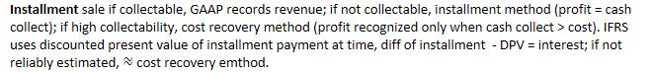
  + **Barter transaction** (non-monetary exchange, round-trip transaction): GAAP can be recognized at fair value only if historical cash, otherwise carrying value; IFRS must based on fair value from similar non-barter with unrelated parties.
  + 
  + Performance obligation: promise to deliver distinct G&S, Transaction price: amount expects to receive in exchange of G&S.
  + Describe general principles of expense recognition, specific expense recognition applications, and implications of expense recognition choices for financial analysis
  + Expenses: amounts incurred to generate rev, **COGS (grouping)**, operating expense, interest, taxes; 1.Cash method 2. **Accrual** method (**matching principle,** in same period of revenue incurred)

3.**Period costs** (eg. Administrative costs) are expenses in the period incurred



* + Gains and losses (economic benefits). Interest expense is usually considered an operating expense for financial firms.
  + 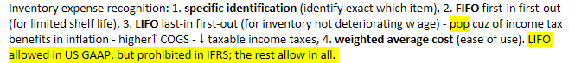
  + 

2. **accelerated depreciation** (recognize more depreciation exp in early years) 3. **declining balance method** (of constant rate, if no residual value, DB never fully depreciate), **double**-**declining** balance



At the beginning of the year, Triple W Corporation purchased a new piece of 
equipment to be used in its manufacturing operation. The cost of the equipment 
was $25,000. The equipment is expected to be used for 4 years and then sold for 
$4,000. Depreciation expense to be reported for the second year using the 
double-declining-balance method is closest to: 

Intangible assets with indefinite lives (e.g., goodwill) are not amortized; however, they must be tested for impairment at least annually; if impaired, impairment amount = expense in IS.

* + Bad debt and warranty expense: matching principle to estimate in the period of sale.
  + Describe the financial reporting treatment and analysis of non-recurring items (including discontinued operations, unusual or infrequent items) and changes in accounting policies
  + **Discontinued operation**: business must physically and operationally distinct from firm - separate report. **Measurement date**: formal plan of disposing of operation. Time in between is **phaseout period**. (estimated loss - accrue during phaseout and sale, expected gain cannot reported until complete sale) Analytical implication: not affect net income, but affect future cash flows.
  + **Unusual in nature or infrequent in occurrence** items: gain or loss from sale of assets or part of business, which not ordinary operations; impairments, write-offs (of bad debt), write-downs, restructuring costs. Analytical implications: review to decide include or exclude.
  + **Extraordinary** items: US GAAP material transaction of both unusual and infrequent in occur, reported net of tax, after income from continuing operation, separately in IS; **stop** after 2015/12/15
  + **Changes in accounting principles**: from 1 GAAP or IFRS method to another (eg. From LIFO to FIFO), **retrospective application**. **Prior-period adjustments**: change of incorrect errors, restated to reflect. **Changes in accounting estimates**: from management of new info, applied prospectively. Under U.S. GAAP, a firm that changes to LIFO from another inventory cost method does not apply the change retrospectively, but instead uses the carrying value of inventory as the first LIFO layer. Analytical implications: changes not affect cash flows, but in estimate or principles need review to decide impact on future operations; error show weak of internal control.
  + Distinguish between the operating and non-operating components of the income statement
  + For financial firms, investment + financial exp = operating. Non-financial firms, nonoperating include dividends and interest from investment, securities, interest expense of capital structure.
  + Describe how earnings per share is calculated and calculate and interpret a company’s earnings per share (both basic and diluted earnings per share) for both simple and complex capital structures
  + Distinguish between dilutive and antidilutive securities and describe the implications of each for the earnings per share calculation
  + Earnings per share (**EPS**): most commonly profitability performance for public-traded, shares of common stock(aka ordinary stocks). **Simple capital structure** contain no ***potentially dilutive*** securities, only common stock + nonconvertible debt + nonconvertible preferred stock. **Complex capital structure** contain potentially dilutive securities(eg. Employee stock options, warrants, or convertible securities). - firms with complex must report **basic & diluted EPS**, **diluted EPS is less than or equal to its basic EPS**(always remember to compare).



Payment of a cash dividend on common shares is **NOT** considered in the calculation of EPS.

* + **Stock dividend**: distribution of additional shares, eg. 10% means holder of 100 shares receive 10 more shares. **Stock split**: division of "old" shares into "new"(post-split) shares, create more shares but price drops, eg. 100 shares will 200 shares for 2-for-1 split, and 150 shares for 3-for-2-split. - SO proportional ownership NOT CHANGED, same % of shares outstanding with more shares: a 50% stock dividend and a 3-for-2 stock split both result in three 'new' shares for every two “old” shares.

example, assume a company began the year with 2,000,000 common shares outstanding and repurchased 
100,000 common shares on 1 July. The weighted average number of common shares outstanding would be 
the sum of 2,000,000 shares x 1/2 year + 1,900,000 shares x 1/2 year, or 1 shares. So the 
company would use 1 shares as the weighted average number of shares in calculating its basic 

Assuming all other evens the same, a previously declared 2-for-1 stock split took effect. Each shareholder of record receives two shares in exchange for each current share that he or she owns.

For EPS calculation purposes, a stock split is treated as if it occurred at the beginning of the period. The weighted average number of shares would, therefore, be 1,950,000 * 2 = 3,900,000 shares.

Johnson Company has 10,000 shares outstanding at the beginning of the year. On April 1, Johnson 
issues 4,000 new shares. On July 1, Johnson distributes a 10% stock dividend. On September 1, 
Johnson repurchases 3,000 shares. Calculate Johnson's weighted average number of shares 
outstanding for the year, for its reporting of basic earnings per share. 
Shares outstanding are weighted by the portion of the year the shares were outstanding. Any shares 
that were outstanding before the 10% stock dividend must be adjusted for it. Transactions that 
occur after the stock dividend do not need to be adjusted. 
PROFESSOR'S NOTE 
Think of the shares before the stock dividend as "old" shares and shares after the 
stock dividend as "new" shares that each represent ownership of a smaller portion of 
the company, in this example 10/1 Iths of that of an old (pre-stock dividend) share. 
The weighted average number of shares for the year will be in new shares. 
Shares outstanding on January 1: 10,000 x 1.10 x 12/12 of the year = 11,000 
Shares issued April 1: 4,000 x 1.10 x 9/12 of the year 
Shares repurchased September 1: —3,000 x 4/12 of the year 
= 3,300 
- -1 000 

* + 
  + Reacquired shares excluded from computation from date of reacquisition
  + Shares sold or issued in purchase of assets included
  + Stock split or stock dividend applied to all shares outstanding prior to beginning weighted average shares, but not applied to shares issued or repurchased after split/dividend date.

|  |  |  |  |  |  |  |  |  |  |  |  |  |  |
| --- | --- | --- | --- | --- | --- | --- | --- | --- | --- | --- | --- | --- | --- |
|  | |  |  |  | | --- | --- | --- | | **Dilutive** securities |  | **Anti-dilutive** securities  ↑EPS if exercised or converted to common stock. | | If-Converted Method | Treasury Stock Method |  | | convertible debt  (which may be dilutive or antidilutive) | stock options  (which are always dilutive) | `same` | |  | **warrants** | `same` | |

* + If the exercise price is greater than the weighted average market price, the effect of their conversion is anti-dilutive. Any **antidilutive** effect of a convertible security only relates to the calculation of EPS, antidilutive is not part of the distinction of simple vs. complex capital structure.
  + 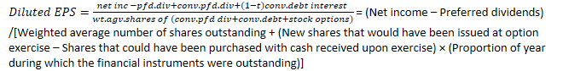

A Diluted EPS Calculation Using the If-Converted Method for Preferred Stock 
For the year ended 31 December 2018, Bright-Warm Utility Company (fictitious) had net income of 
Sl The company had an average of 500,000 shares of common stock outstanding, 20,000 
shares of convertible preferred, and no other potentially dilutive securities. Each share of preferred 
pays a dividend of SIO per share, and each is convertible into five shares of the company's common 
stock. Calculate the company's basic and diluted EPS. 
Hide Solution 
Solution: 
If the 20000 shares of convertible preferred had each converted into 5 shares of the company's 
common stock, the company would have had an additional 100,000 shares of common stock (5 
shares of common for each of the 20,000 shares of preferred). If the conversion had taken place, 
the company would not have paid preferred dividends of $200,000 (SIO per share for each of the 
20,000 shares of preferred) As shown in Exhibit 11 , the company's basic EPS was and its 
diluted EPS was $2.92 
Exhibit 11 
Net income 
Calculation of Diluted EPS for Bright-Warm Utility Company Using 
the If-Converted Method: Case of Preferred Stock 
Preferred dividend 
Numerator 
Weighted average number of shares 
outstanding 
Additional shares issued if preferred 
converted 
Denominator 
EPS 
Basic EPS 
$1 , 750,000 
-200000 
500,000 
0 
500,000 
$3.10 
Diluted EPS Using If-Converted 
Method 
Sli750;ooo 
0 
Sli750;ooo 
500; 000 
100000 
600; 000 
$2.92 

* + A Diluted EPS Calculation Using If-Converted Method for Convertible Debt Company O(fictitious) reported net income of $750,000 for year ended 31 December 2018. The company had a weighted average of 690,000 shares of common stock outstanding. In addition, it has only one potentially dilutive security: $50,000 of 6 percent convertible bonds, convertible into a total of 10,000 shares. Assuming a tax rate of 30 percent, calculate Company O's basic and diluted EPS.

Basic 
EPS 
$750;ooo 
Net income 
After-tax cost of interest 
$750;ooo 
Numerator 
Weighted average number of shares 
690,000 
outstanding 
If converted 
Denominator 
690,000 
$1.09 
EPS 
Diluted EPS Using If-Converted 
Method 
S750,ooo 
2,100 
S752, 100 
690,000 
10000 
7007000 
$1.07 

A Diluted EPS Calculation Using the Treasury Stock Method for Options 
Hihotech Company (fictitious) reported net income of $2.3 million for the year ended 30 June 2018 and 
had a weighted average of 800,000 common shares outstanding. At the beginning of the fiscal year, the 
company has outstanding 30,000 options with an exercise price of $35. No other potentially dilutive 
financial instruments are outstanding. Over the fiscal year, the company's market price has averaged 
$55 per share. Calculate the company's basic and diluted EPS. 
Hide Solution 
Solution: 
Using the treasury stock method, we first calculate that the company would have received 
$1 ($35 for each of the 30,000 options exercised) if all the options had been exercised. 
The options would no longer be outstanding; instead, 30,000 shares of common stock would be 
outstanding. Under the treasury stock method, we assume that shares would be repurchased with 
the cash received upon exercise of the options. At an average market price of $55 per share, the 
$1 proceeds from option exercise, the company could have repurchased 19,091 shares. 
Therefore, the incremental number of shares issued is 10,909 (calculated as 30,000 minus 19,091). 
For the diluted EPS calculation, no change is made to the numerator. As shown in Exhibit 13, the 
company's basic EPS was $2.88 and the diluted EPS was $2.84. 

As noted, IFRS require company to consider that any assumed proceeds are received from the issuance of new shares at the average market price for the period. These new “**inferred**” shares would be disregarded in the computation of diluted EPS, but the excess of the new shares that would be issued under options contracts minus the new inferred shares would be added to the weighted average number of shares outstanding.

Note that this is the same result as that obtained under US GAAP; it is just derived in a different manner. IFRS refer to 19,091 shares the company would have issued at market prices as inferred shares.

* + An Antidilutive Security

For the year ended 31 December 2018, Dim-Cool Utility Company (fictitious) had net income of $1,750,000. The company had an average of 500,000 shares of common stock outstanding, 20,000 shares of convertible preferred, and no other potentially dilutive securities. Each share of preferred pays a dividend of $10 per share, and each is convertible into three shares of the company’s common stock. What was the company’s basic and diluted EPS? - effect of Antidilutive security conversion not included

Net income 
Preferred dividend 
Numerator 
Weighted average 
number of shares 
outstanding 
If converted 
Denominator 
EPS 
Basic EPS 
$1 , 750,000 
-200,000 
500,000 
500,000 
$3.10 
Diluted EPS 
using If- 
Converted 
Method 
500,000 
60,000 
560,000 
$3.13 
—Exceeds basic EPS; security is 
antidilutive and the effect of 
their conversion, therefore, not 
included. Reported diluted EPS = 
$3.10. 

* + Convert income statements to common-size income statements
  + Evaluate a company’s financial performance using common-size income statements and financial ratios based on the income statement
  + A vertical **common**-**size** expresses category of income statement as a percentage of **revenue**. One exception is income tax expense, expressed as a percentage of pretax income; the result known meaningfully as the **effective tax rate**.
  + 
  + Describe, calculate, and interpret comprehensive income
  + Describe other comprehensive income and identify major types of items included in it
  + Anything affects IS (net income) will be added to shareholders' equity - **retained earnings**. **Comprehensive income** is a more inclusive measure that includes all changes in equity except for owner contributions and distributions, therefore sum of Net Income + Other comprehensive income:

Comprehensive income = (Ending shareholders equity – Beginning shareholders equity) + Dividends paid

1. Foreign currency translation gains and losses.

2. Adjustments for minimum pension liability.

3. Unrealized gains and losses from cash flow hedging derivatives.

* + 4. Unrealized gains and losses from **available-for-sale securities**(investment not held to maturity or just sold), realized securities report on BS at fair value, unrealized aren't reported in IS but under share's equity as

**other comprehensive income** - revenue less expense items excluded from the net income calculation; securities held for trading recognized in net income and NOT OCI.



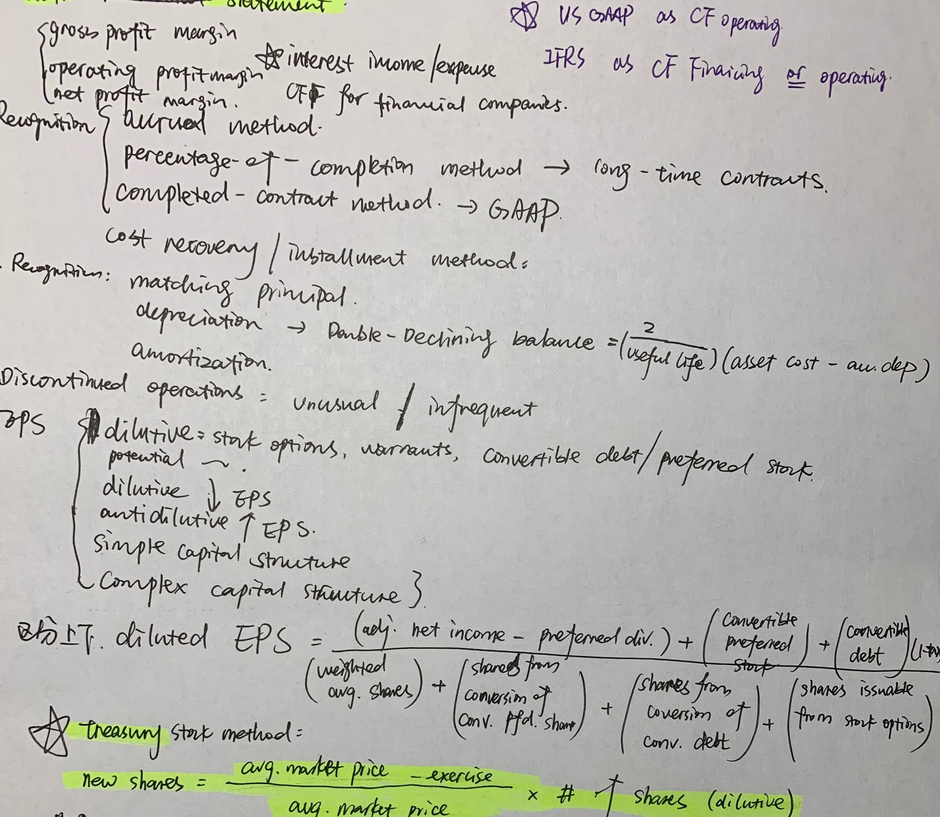













ورث/ (ه 
NL .ربر 
لن 1/ناعها 
أS ب ها ا كره 
٣ بم . وهو D 
٢ 
؟.لهةا 
( .( فسد سعد . 
اج ؟ ٨،مم ٥ ٨ ١ 
]i 60 -رح 
و .لا «إلا . 
بندا:0 لمه 
و ر 
و ( سرو رح 
.2و بر سم 
لا حم؟ دن ا مص. 
,)optim 
Je لا æ€ 
٣ مصو 
الوععءم7 ( مم Inu 
ممنهe» مذلا p محمم ٧٧ 
إ// p ) وسه باد، 
50 
أ- لمعاعم٨) 
S ٥9. 
hon 
m,.-nqatM : لا نن 
١١. 
٤ 
eلا«.٥ؤلا ر.م 
٥ . ( l 
. 
لآلا ٩3■ 